
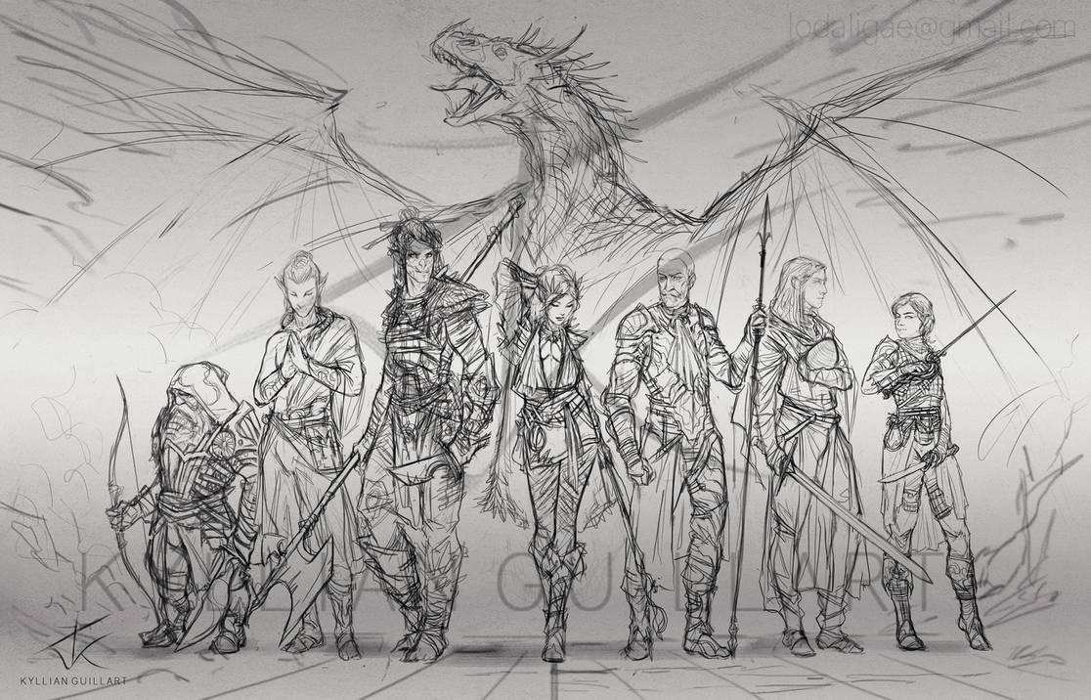
Roleplaying Social Club
  - The ABCs and KPIs of RPGs.
by Marcin Jędrecki

Foreword
This document is my fun way to pitch an idea about organizing and maintain a social club in Fujitsu – starting from the ARM Service Desk, potentially growing out to include people from the entire .KTW office and, thanks to the wonders of the internet – maybe even other offices.
Why is it fun? Because come on, the things I talk about in this document have no business being written on office “stationery” and with adherence to style and language guidelines, but if nothing else comes of it, I enjoyed the exercise of presenting a topic close to me in a way that might entice a few chuckles. And if it achieves its goal, I’d like to think that my writing skills aren’t as rusty as I had thought.

So what’s this RPG nonsense all about?
Quote from Wikipedia:
A role-playing game (sometimes spelled roleplaying game; abbreviated RPG) is a game in which players assume the roles of characters in a fictional setting. Players take responsibility for acting out these roles within a narrative, either through literal acting, or through a process of structured decision-making regarding character development. Actions taken within many games succeed or fail according to a formal system of rules and guidelines.
A bit dry, isn’t it? Let’s break it down and expand on each characteristic, at least on a basic level, as each of these could be talked about with no end in sight.
  - Assume the roles of characters in a fictional setting:
You can literally be anyone you can imagine. A Dragon-slaying knight in a fantasy realm? A gumshoe in 1930’s New York that stumbles into the world of eldritch horror straight from H.P. Lovecraft? A half-cyborg in the dystopian future of Cyberpunk? Or maybe a superhero, with laser-beams for eyes? All that and infinitely more awaits, if you dare take the plunge.
  - Acting out these roles within a narrative:
One of the players assumes the role of a Game Master (sometimes called the Dungeon Master, Narrator, Storyteller, depending on the chosen setting; In this document these and other terms may be used interchangeably) – they know everything about the world you play in, they craft it on the go, letting the events lead the story, or prepare ahead of time all the minutia, from the non-player characters to the encounters and conflicts in the storyline. It can be a daunting task, but some say that crafting a story that’s fun and engages the other players is reward enough.
  - Structured decision-making regarding character development:
How you develop your character is totally up to you. You can “drive” your character any way you like. You can align the actions, morals and motivations of your alter-ego with your own, essentially playing yourself or, go off the rails a bit – do something you wouldn’t, act outside your comfort zone, or be your own polar opposite and everything in-between.
  - A formal system of rules and guidelines:
Well, I fibbed that last part a bit. As in real life, there are certain limitations to what you can do, but they can be as lax or strict as the chosen game system permits. Furthermore, the rules are flexible and can be modified or retired altogether if they do not suit your group’s playstyle. Still, there will be things you can and can’t do, but that’s a story for another time.

So how does this benefit a company?
The RPG experience carries many benefits, ranging from social interaction to personal and team growth. While most of these would not be canonically qualified as business-related, the soft skills involved in RPGs can have a direct influence on a person’s professional development as well.
Going over the segments discussed in the previous section, let’s take a look from a different angle – what benefits they give the involved people.
Roleplaying a different character puts the player in the shoes of someone different to themselves, even if only marginally. This helps to develop empathy, a trait welcome in a multinational, multicultural corporation, or in any other social circumstance.
Acting within a narrative and the Storyteller’s role work in tandem to develop quick thinking, creativity and teamwork. Mock conflicts of varying nature help improve negotiation skills, strategic thinking and planning. The Game Master needs to be knowledgeable about the story he’s crafting.
Character development, both in the game mechanics sense as well as ‘personal growth’, helps players plan ahead, anticipate and react to the changing environment presented to them by the Narrator. In fact, actions taken in this field may present the DM with opportunities to change the story to better suit what the characters are growing into – recognizing potential and acting on it to create an enjoyable experience.
Finally, a formal system of rules and guidelines, helps players understand the world they inhabit, work within its constraints but also use those rules to their advantage.

Untangling the arcane
As any new niche hobby, diving into the world of RPG’s can seem daunting but it has only one learning curve – understanding that it really is a hobby for everyone - by virtue of being so expansive, everyone can find their own patch of pleasure in it.
An RPG game in a more esoteric, poetical sense, can be compared to a theatrical play: Players are Actors, the Game Master is the Director, Writer and Scenographer, and the Rules are the Script. The “game” part is usually represented by a roll of dice, sometimes by a deck of cards, but more unusual randomness generators can also be utilized or sometimes omitted altogether.
Just like an Actor in a play, Players get to define their characters, but in a much wider capacity. They can define their biometrics as well as talents, skills and knowledge. Sometimes even supernatural abilities can come into the mix. These are usually recorded on “Character Sheets” – allowing players to track and update their progress.
The Game Master writes the story for the characters with the aid of the Rules. They can range from simple guidelines and limited to only a few stats to strict and in-depth development systems.
To add a bit of uncertainty into the experience, a randomness generator is used as Fate – whenever (not 100% of the time, necessarily) a Character faces a challenge to overcome, they perform a test using various dice (a classic six-sided die is called a ‘d6’, similarly a 4-sided one is a ‘d4’, a 20-sided is a d20 and so forth). Sometimes additional modifiers are added (say, a character is proficient in cryptography and they found an old ciphered letter – they have a natural advantage against that particular test, or a character with a broken leg is trying to jump – a natural disadvantage, so the test is harder).
The randomness obviously leads to unintended results some of the times – these can range from simple failed or passed tests to ones that fail or succeed… spectacularly. And, on rare, treasured occasions, side-splitting hilariously.

Essential resources
Disclaimer: This paragraph is a very light-hearted joke.
Like any hobby, RPGs have their own requirements and needs to be fostered. If you decide to jump in, be prepared to pay the toll for the fun:
- Time – a session can take anywhere from 2-5 hours, depending on the Game Master’s arsenal of tricks and the player engagement)
- MORE Time – sessions are most often chained into campaigns with the story following from one chapter to another. Think of it like a TV Series – some have only one season and wrap-up a conclusion in 4-5 sessions, while those ‘most epic’ campaigns can span years in real-life and (if the setting allows) millennia in game-time. If you are familiar with the Dragonlance series of books, they are novelized RPG sessions that are an example of the latter
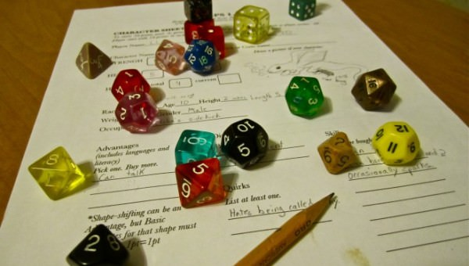
- Cash – it’s nice to have each player equipped with a set of dice dependent on the game played. While some systems require one kind of die (AGE uses three ‘d6’, World of Darkness uses ‘d10’s in various amounts) other require at least one of each kind of the most common ones. A basic set of dice is under $5, although some games have unique dice and those can get pricier. Also, since the Rules are in Rulebooks – having one is a good thing (there are PDF versions as well, paper editions are just traditional), but usually only one copy per group is needed (so a chip-in by the involved players is possible). Plus additional expansion books, if any. Depending on the game, a rulebook (or set thereof) can range from $20 to $60.
Also, stationery (pencils, erasers, paper), but that’s chump change.
- Attitude – remember that it is all in good fun. Keep the real world out of the game. And the game out of the real world. Share your fun and excitement with other players and you will be rewarded with the same.
In other words: Don’t be a d*ckhead.
- Snacks and drinks – saving the world, princess or your friends is exhausting. Stay recharged and hydrated. Soda, chips, cookies are all an RPG-player’s necessities, but a successful finish to a grueling quest or closure of a campaign deserves pizza! Celebrate with your teammates on a job well done.
One final constraint: Space – usually, RPG sessions take place in person – the GM and 2-6 Players seat around a table in a space where no-one disturbs them and vice versa. There are gaming shops that can have rooms for groups and even rulebooks on lend and sometimes they even hold publicly open gaming events. However, the hobby canonically evolved from people meeting at a friend’s house. In today’s world (as I write this in mid-July 2020, at the height of the COVID-19 pandemic) online solutions are taking over – a game can be boiled down to a narrative with only voice capabilities required – TeamSpeak, Discord are just two apps that can facilitate a Corona-proof gaming experience.

Additional resources
The topic of RPGs is so expansive, that this document would never hope to encapsulate all facets of it. The following table is a loose selection of materials that expand on the topic. There are more like these, Google knows them all.
Resource | Description
Titansgrave: Ashes of Valkana | A 10-episode (10+ hours) recording of an RPG session created, narrated and explained by Wil Wheaton (Wesley Crusher from Star Trek: The Next Generation, himself, arch nemesis of Sheldon Cooper on Big Bang Theory), using the Adventure Game Engine in a world he crafted himself. He invited four of his friends (all of whom are renowned voice actors, so role play is their bread and butter) and together they crafted a great story, full of drama, action, emotions and fun. You can watch it like a movie or tv series, but it’s also podcast-able.
Reddit.com’s r/rpg Beginner’s Guide | A well thought out ‘RPG 101’ Handbook-style article, full of in-depth, but accessible explanations of most terms, loaded with links to various resources, including a test designed to check which RPG systems and genres a person might enjoy most.
What is a Tabletop RPG? (Beginner's Guide)  by Xiomaro | What this document fails to convey in 1998 words, this article does in eight minutes, using one of the most popular (if not #1) RPG of all time, Dungeons & Dragons.
Beginner’s Guide to Dungeons&Dragons | If you’re more the reading type, this behemoth, 11-page article, should be a decent primer into the world of DnD.
The Gamers movie | A tongue-in-cheek satire on the hobby, told from the perspective of the players gathered around the game table and through the eyes of their respective characters. What the movie lacks in its low-budget production value it makes up in troves with references, jokes and sometimes crude humor.

Shameless plug
As it stands, I am an accomplished, RPG-deprived player, on-and-off Game Master with around 10 years of experience. I am slowly crafting my own world based on an easy to pick up ruleset. Interested? You know where to find me – email on title page.

